Python1

Python2

Python3

Python4

Python5

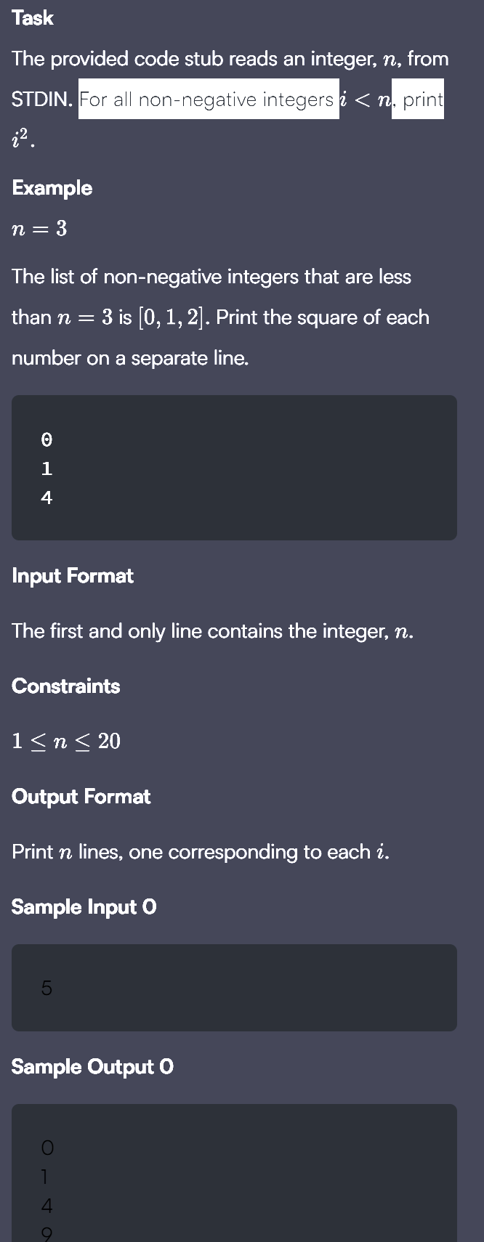

Python6

Python7

Python8

Python9

